STUDENT NAME: JESUS IVAN LOPEZ VILCHIS

ASSIGNMENT: VBA CHALLENGE

SCREENSHOTS FOR EACH YEAR OF THE RESULTS ON THE MULTIYEAR STOCK DATA

Please note that a separate pdf and txt files are submitted with the complete outputs

**Year 2016**

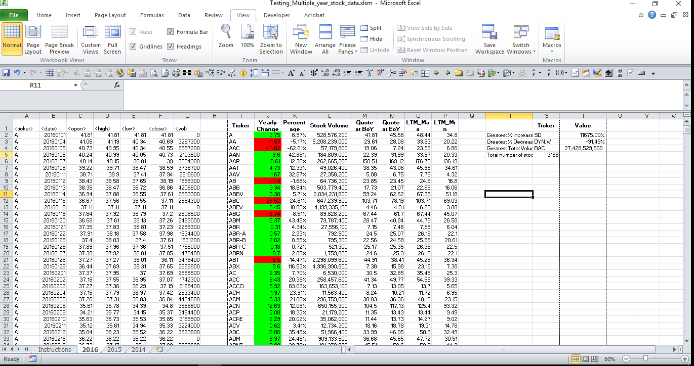

Year 2015

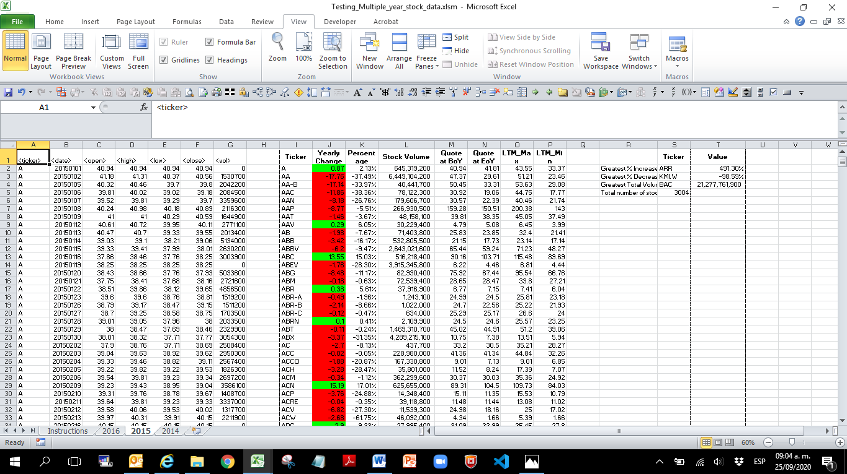

Year 2014

